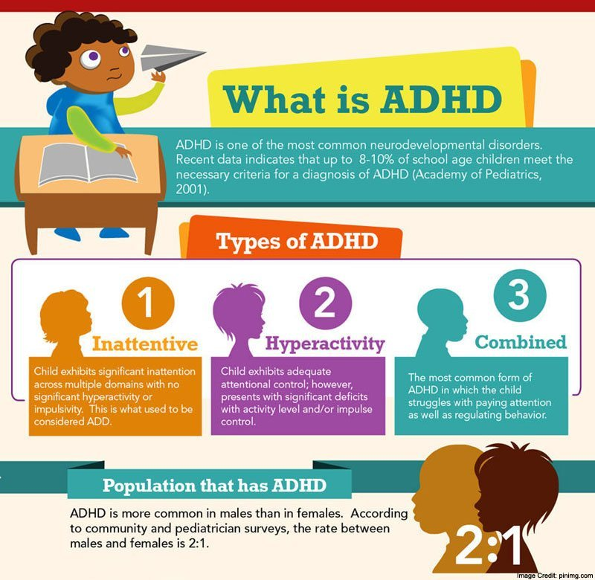
Will crop out the bottom statistics.
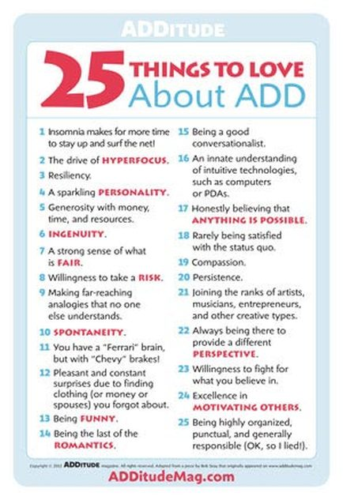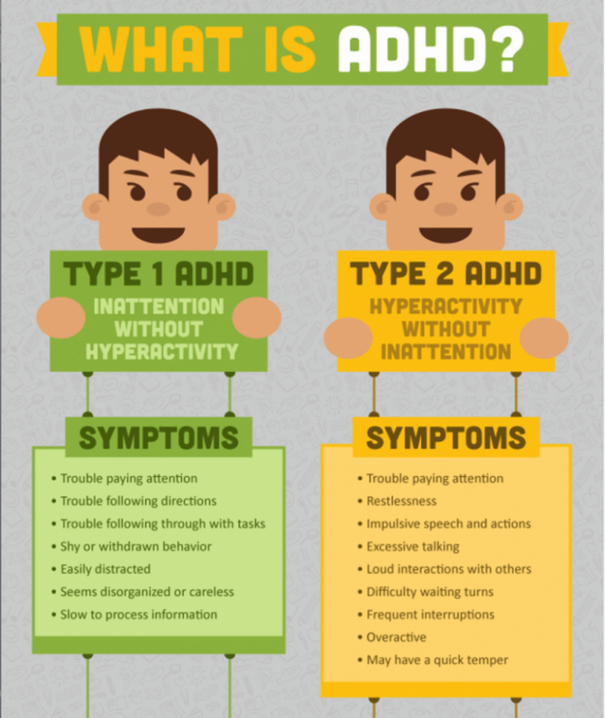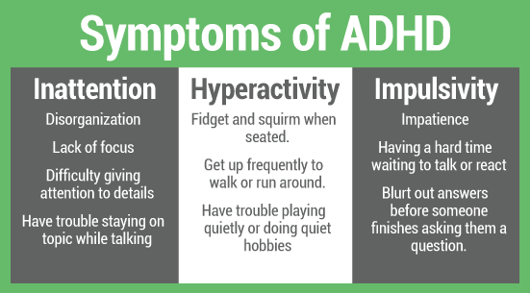

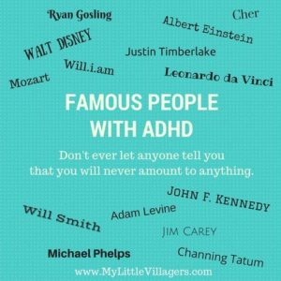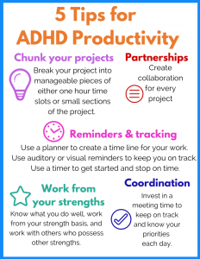

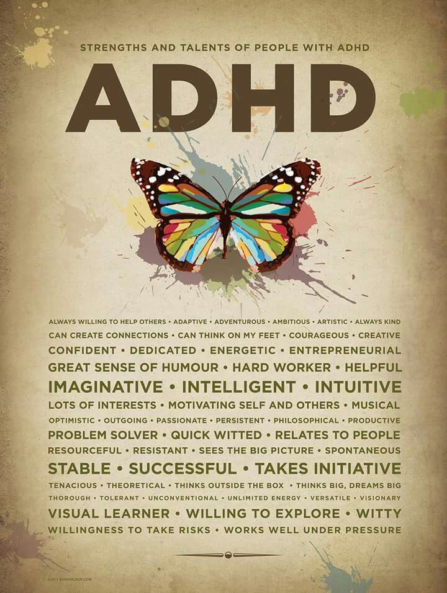

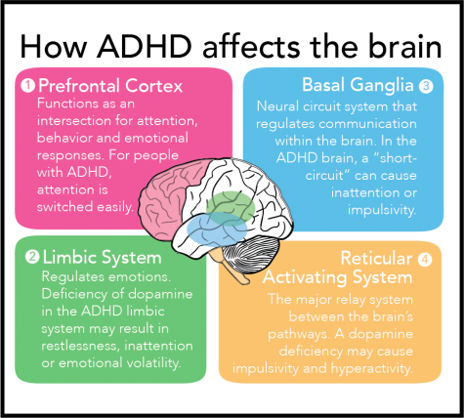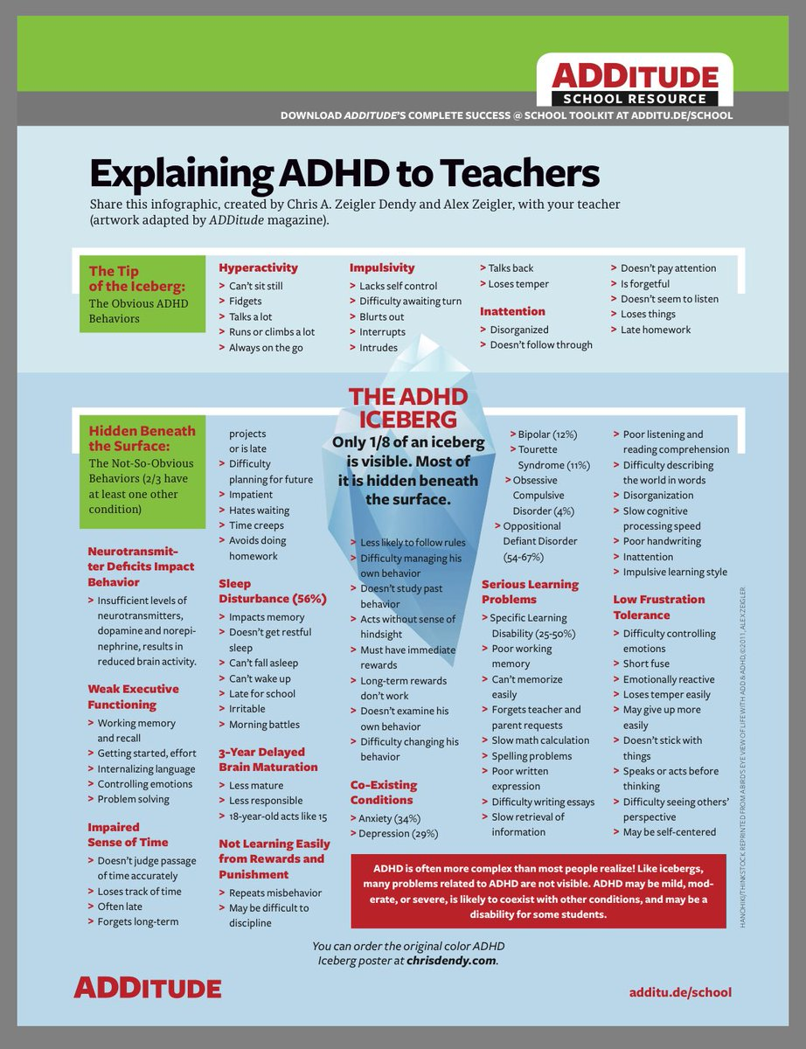
Will crop the “Teachers” part out

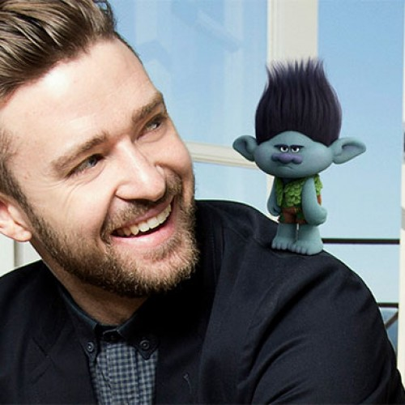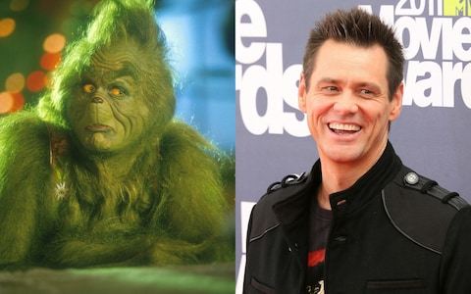
Justin Timberlake
“Kids at school would call me weird… but luckily my mom taught me that being different was good, that being different meant you could make a difference.”

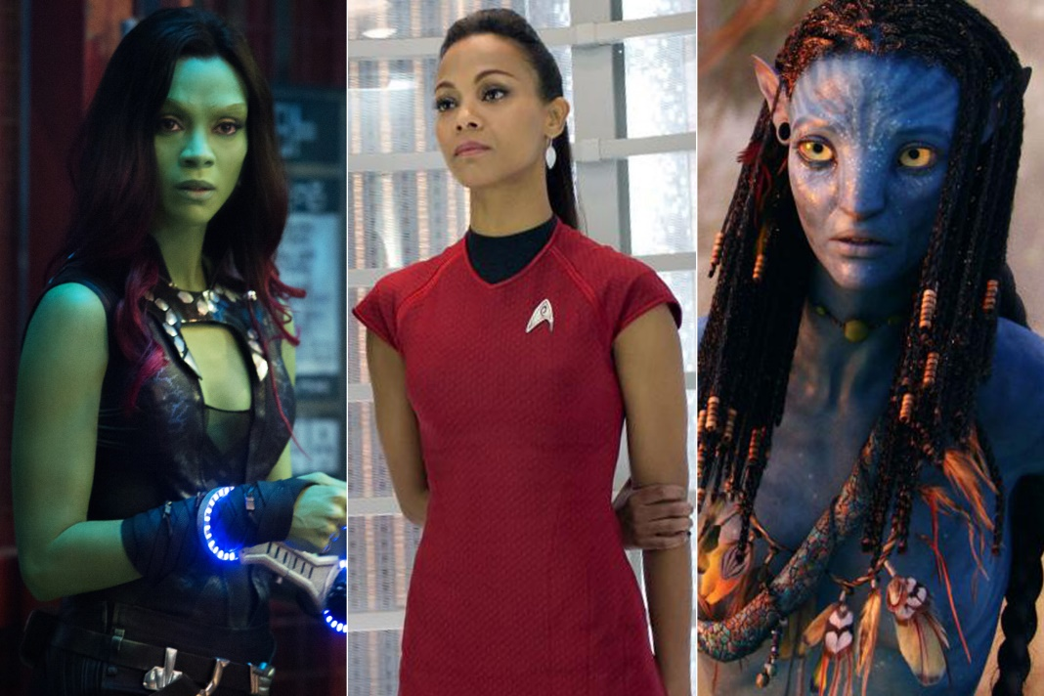
Zoe Saldana
“Who you are and what you’re going through is not wrong. If you use your voice and speak up, then you can get help — from a teacher, a friend, a parent, a hotline, a website. Speak up. You deserve to be heard.” - @Zoe Saldana talking to her younger self about dyslexia and ADHD.

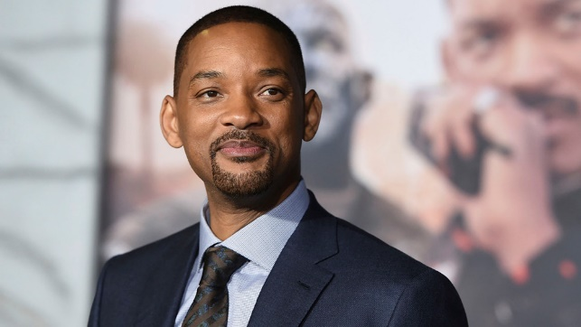
Will Smith
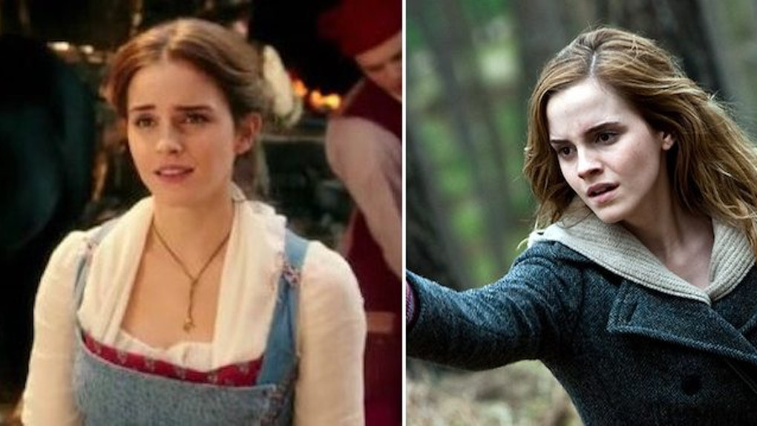
Emma Watson
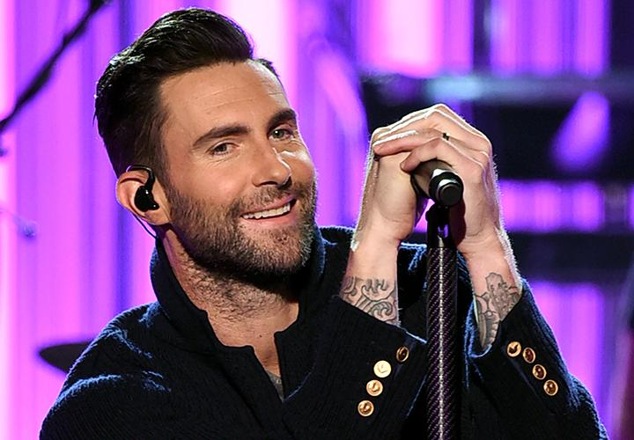
Adam Levine
“I had trouble sometimes writing songs and recording in the studio. I couldn’t always focus and complete everything I had to. I remember being in the studio once and having 30 ideas in my head, but I couldn’t document any of them,” he wrote.
He went back to the doctor and learned that the ADHD hadn’t gone away as he’d grown up. In fact, he still deals with it daily.
“ADHD isn’t a bad thing, and you shouldn’t feel different from those without ADHD,” he wrote. “Remember that you are not alone. There are others going through the same thing.
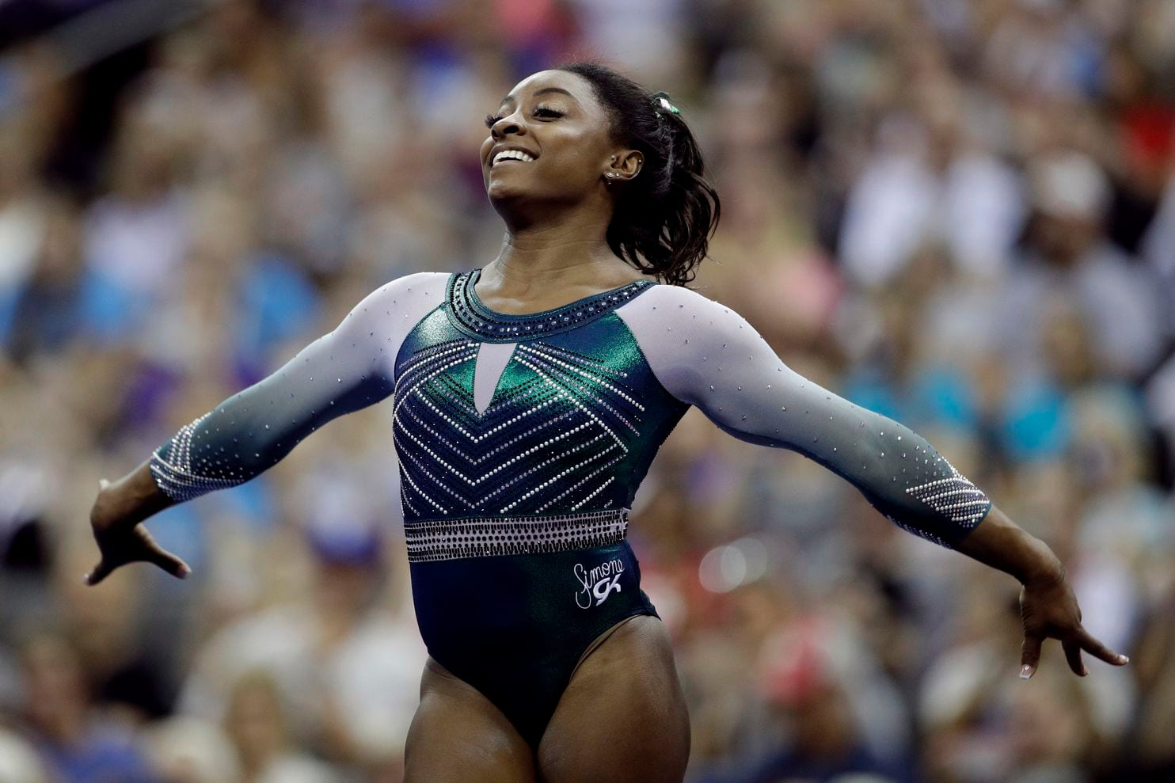
Simone Biles
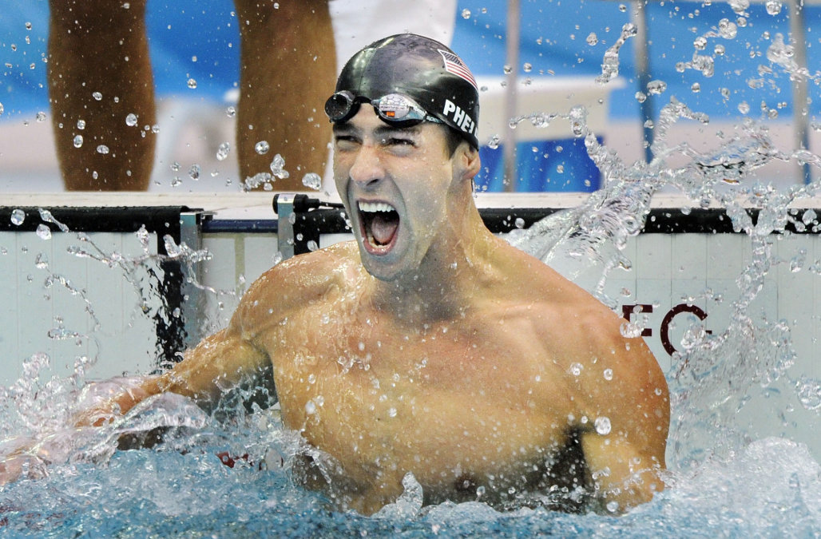
Michael Phelps
Channing Tatum

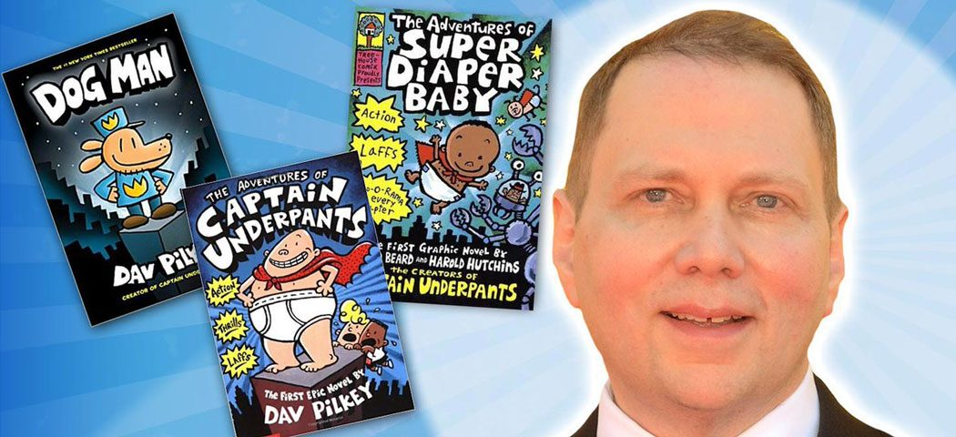
As a child, Dav Pilkey was diagnosed with dyslexia and ADHD. Dav was so disruptive in class that his teachers made him sit out in the hall every day. Luckily, Dav loved to draw and make up stories, so he spent his time in the hallway creating his own original comic books.
In the second grade, Dav Pilkey created a comic book about a superhero named Captain Underpants. His teacher ripped it up and told him he couldn’t spend the rest of his life making silly books. Fortunately, Dav was not a very good listener.
Dav has gone on to create award-winning and bestselling books for children. His Captain Underpants series has more than 80 million copies in print worldwide and has been translated into more than 28 languages. In 2017, DreamWorks Animation brought the character to the silver screen in the feature film adaptation Captain Underpants: The First Epic Movie, and Netflix is now streaming The Epic Tales of Captain Underpants TV show.
Dav’s latest creation, Dog Man, continues to be a #1 New York Times bestselling series with more than 13 million copies in print worldwide and translations available in more than 21 languages. Dav is also the creator of the Dragon series, the Dumb Bunnies series, Dog Breath, and The Paperboy, which is a Caldecott Honor Book.

