What is Empathy?
Empathy is the ability to understand and care about how someone else is feeling or to understand the situation they are in. It is the ability to “put yourself in someone else’s shoes” and to understand the way a situation might make them feel. Even if you have not been in the same situation, you can try to imagine what it may be like.
Empathy is important. It allows us to be a good friend and to work well as part of a team.
Can you think of a time someone showed empathy towards you?

Shared Emotion
First, empathy is about sharing an emotion with someone, or feeling the way they feel, even if you aren’t in the same situation. When you feel an emotion along with someone, even if you aren’t directly affected by whatever is causing their situation, that’s empathy.
Example 1: Have you ever felt sad with a friend just because he was sad? That’s empathy! So for example, if you feel sad with your friend because he didn’t make the soccer team (even though you aren’t affected by him not making the team) that’s empathy. Sharing his sadness is a kind of empathy.
Example 2: Have you ever been with a friend who just got a new toy and she’s so excited about it and you get super excited too? If you are feeling excited because you know how great it can feel to get a new toy (even though you didn’t get a toy and you aren’t playing with the toy) that’s empathy. Being excited with and for your friend is a kind of empathy.

Seeing others Perspective
The second part of a definition of empathy is about being able to understand someone else’s way of looking at a situation, even if you see it differently. We often call this “putting yourself in someone else’s shoes” and it means you see things from their point of view, or from their perspective. Having empathy means you can step back from the way you see a situation and think about how someone else might feel from their side of the story.
Example: Have you ever thought a game was really fun but your friend felt it wasn’t fair? If you saw your friend was bothered by the game and understood she wasn’t having a good time even though you were… that’s empathy. You showed empathy by understanding how things felt from her side of the situation.

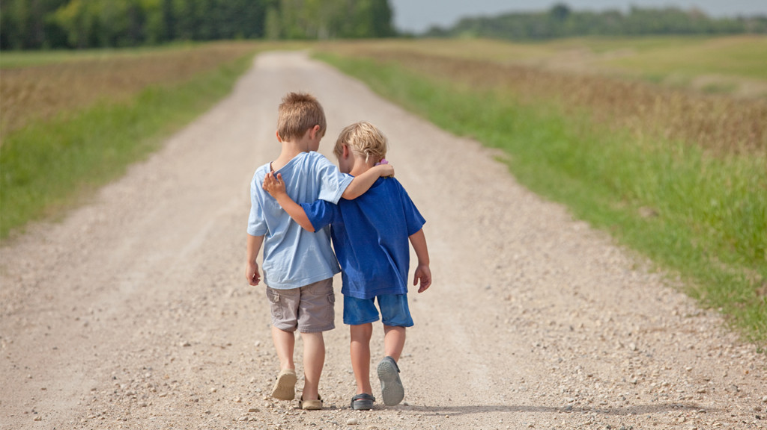
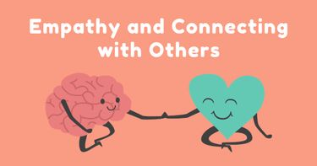
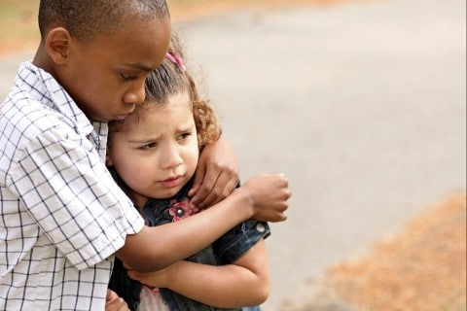

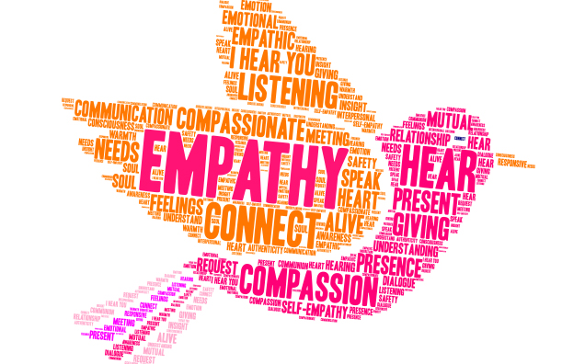

Resources:
Talking with Trees, What is Empathy?
Sesame Street, Mark Ruffalo, Empathy
https://www.scholastic.com/teachers/articles/teaching-content/ages-stages-empathy/
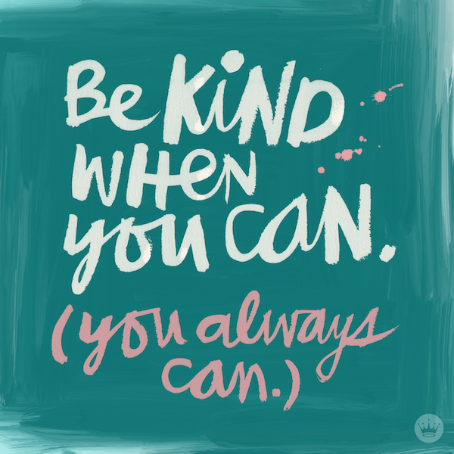
For Parents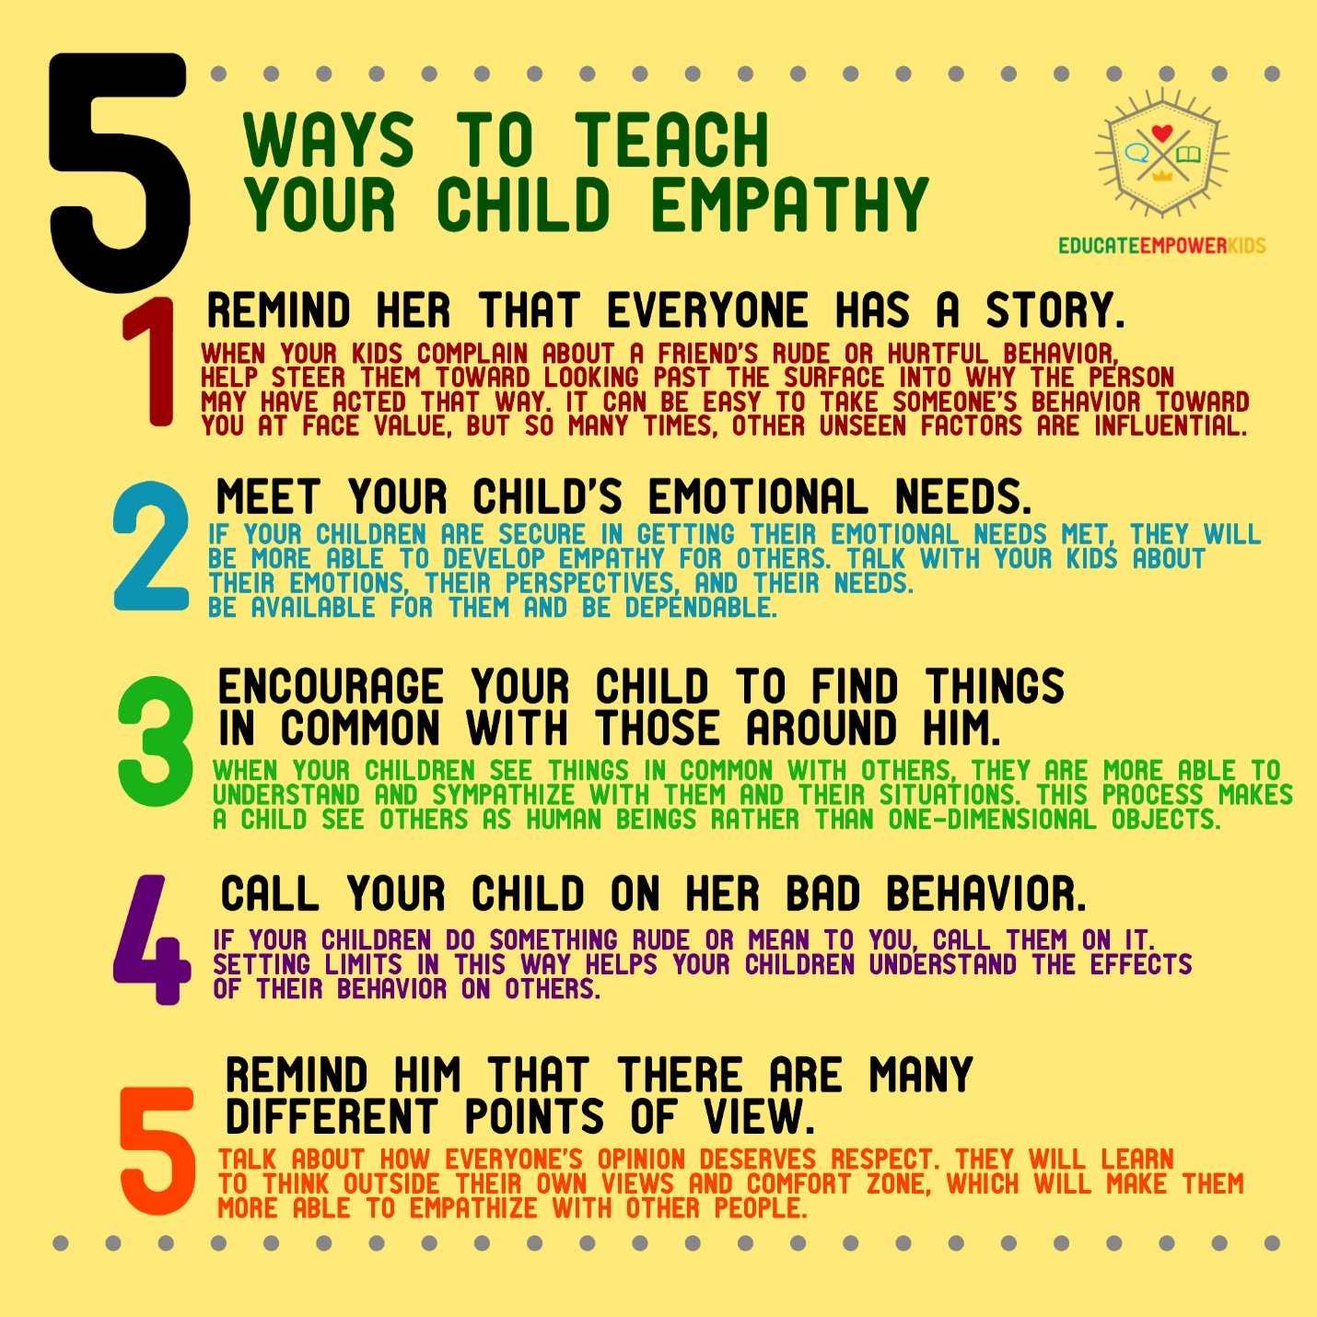
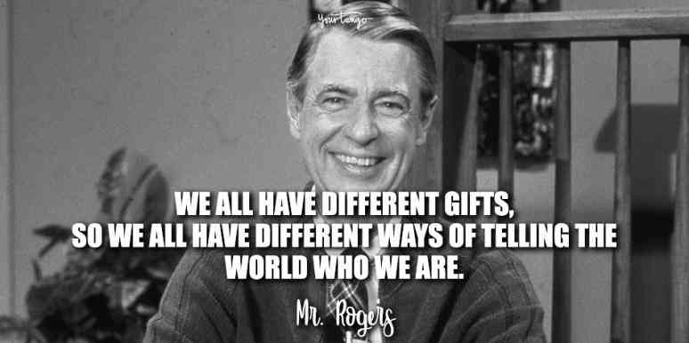

Diane Elizabeth is with Laura JCrimeni.
August 10 at 11:28 AM
Only days ago we were playing in the backyard with my new puppy, taking photos and chatting about life. You laughed as I pulled acorn after acorn out of his mouth and we stomped around in the thick leaves so he could pounce on our feet. It was funny. It was easy. You laughed the whole time.
We raised you as a family from a brand new baby boy - you were all of ours. I took you to soccer practices and coloured pictures with you. You even let me paint your nails once. You were only three, and you thought it looked great. So did I.
In true Italian style you loved food and to cook. You always wanted to make the family dinner. Even the last day I saw you, you barbecued us ribs. So happily, so generously.
You loved to make everyone laugh, you were goofy, you were silly. A jokester and a clown. You wanted recognition and friendship above all else. You just wanted to belong.
This boy was so loved. His father’s best friend and his auntie’s greatest gift. He was the treasure of our family. He was beautiful. His blue eyes were perfect and his blonde hair was one of a kind in our family. He was our only child.
Losing a child is one thing. Losing a child to his own mistakes is another. But losing a child to the inhumane acts of others for their own entertainment is completely unfathomable. He was just a boy. A teenager with a life ahead of him. He was ours... and now he is gone.
How anyone could have done this to you hurts my soul in a way I cannot express. The lack of humanity, exploiting him in his final hours of suffering. Throwing his cell phone into a garbage can. Taking his shoes and leaving him to die alone. Laughing at his pain. It is inhumane. It is evil. It is unthinkable and it is unbelievable. It’s a side of humanity you don’t think can exist - and it took our little boy from us.
We are grateful for the community coming together and the people who have come forward. Nothing will bring him back or change how he died. But we truly appreciate the support that has been pouring out.
If anyone has information we ask you to please come forward - anonymously if you choose. We are looking for answers, understanding, and closure for this beautiful boys life. We never want this to happen again - and it doesn’t have to if we stand against it as a community.
Rest in peace sweet Carson.
We love you.
Can you think of a time someone showed you empathy? Or a time you showed empathy to others? Please share to help others feel inspired.
If you feel nervous, ask a teacher for help.

